JDBC Report

OOP | 03/12

(Names)

1. Ahmed Nasser Abdelkareem Mohamed (9)
2. Ahmed Khaled abdelsayed abdelaal (5)
3. Mohamed esmail Mohamed Ali (53)
4. Bassam Ashraf elsayed Mattar (16)
5. UML
6. Design Describtion :
7. MyDriver :

It’s an implemented Interface that enabled java Application to deal with Database Files By using Connect Method .

1. MyConnection :

It’s a relation between java application and database and It’s First step to create Statement .

1. MyStatement :

It’s a factory of ResultSet that provides methods to execute queries with the database .

1. MyResaultSet :

It’s a cursor pointing to a row of a table and getting valuable information from table .

1. MyResultSetMetaData :

Contains much info about coloumns like labels and dataTypes and etc …

1. JarReflecion :

It’s used to get Jar Library and get the driver from it to access databases without using DBMS .

1. GUI

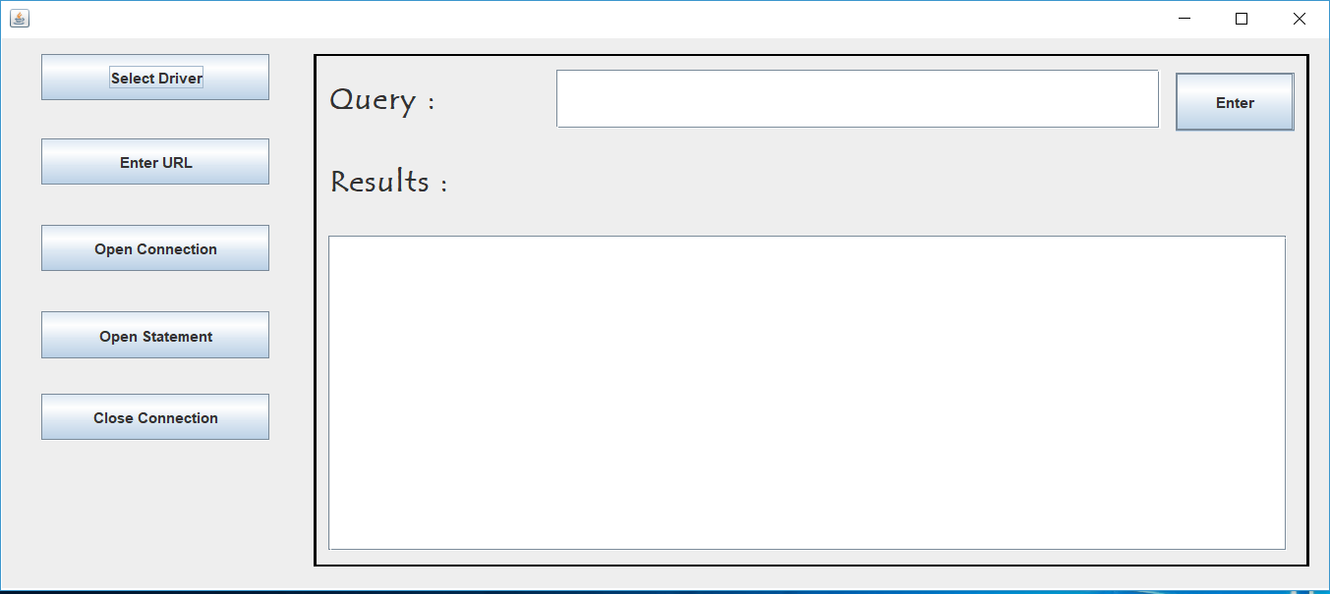

1. User Guide
2. You need to select driver which is a Jar file contains Dbms and Jdbc Library .
3. Press ENTER Url to write your url which is “jdbc:xmldb://localhost” in our case.
4. Openning Connection to your Database .
5. Openning Statement which access all methods in DataBase By Given Query.
6. Going to the borded panel , you have to write your query in the textfield area .
7. Then you can press Enter to get Results in the TextArea .
8. You Can later Close Connection after finishing your requests .